Kathleen Schnuck

Chris Friend

ENC 1102

March 21, 2013

Primary Research Report: Too Tattooed?

**Stakeholder Analysis**

There are two stakeholder groups that I will focus on conveying my research results with at the end of this project. These groups will care the most about the results of my primary research because it involves these groups on a daily basis in their professional life. The groups are hiring managers for any type of business and college students who intend to join the professional world.

Hiring managers will care about this information because they do the hiring at their corporation. It is important for me to reach these people because they are the main part of turning a stranger into a successful member of the corresponding business. It is their responsibility to make sure they hire appropriate people to represent the message of their business while doing a good job. The topic of tattoos in the workplace and how they can affect a professional career is directly correlated to the opinions of the people hiring the professionals. The hiring managers need to know the most up to date information on how future professional’s they can hire are viewed by their co-workers, managers, and most importantly, the clients. It is also a point of mine to take the information found and apply it to the idea of changing opinions towards tattoos and their increase in acceptance as time moves on.

It is a major concern for this stakeholder to make the right decision in which they hire to convey the right message for their business. This stakeholder can review the results from my research and use this in their hiring to make a more informed decision on what the tattoos on the individual may or may not mean for their success. Not only is it important for the hiring manager to understand how their business may be affected, but also for the hiring manager to notice what possible effects of this person’s tattoos may have on their success within the company.

My second stakeholder group is college students, because they are working towards a degree to prepare themselves for the professional world. This group is significant because it is important for the college students, who are at the age when getting tattoo(s) is highest, 29.4% of 8656 people surveyed from 16-64 years old (Heywood, 51). Also, because college students need to be aware of any possible hindrances to their ability to obtain a successful job after graduation. I plan to share with college students at UCF my results in the hopes to bring to student’s attention the possible effects on their future career from getting visible tattoos. I hope this information will get students planning to get a visible tattoo to make sure they consider all of the aspects of adding a visible image to their body and what possible effects can come from this decision.

I believe the most beneficial people to share my research to are hiring managers and college students. Because I am choosing to focus on two stakeholders to present my final report to, I will be providing two Genre Analyses, as seen below.

**Genre Analysis**

For my stakeholder of Hiring Managers I chose a genre that I thought would convey my message to the most hiring managers that one source would be able to do. It was difficult to find one medium that would reach all hiring managers specifically because they all are of varying age, sex, lifestyles, and interests. For my genre I chose to use hiring managers websites, not explicitly called “HiringManagers.com” though I found through my researching that Human Resources (HR) websites were the most available and more widespread to make my contact the most beneficial. On these HR websites you can find information displayed in a context suitable for an established professional or corporation. There is a wide variety of information that any corporation would find valuable in order to make sure all HR rules and regulations are followed and within the regulations of federal law. Because of most of the information provided on these websites is legal information based on state and federal laws, hiring managers can log on to find legal information for their business. One of these website is [www.shrm.org](http://www.shrm.org/), or the Society of Human Resource Management. This site requires membership with an annual fee, as do many other HR websites, so I am unable to go deeply into the sites to see specifically how information is conveyed. In order to have a membership at this site, you must complete a 2-page application describing your current position at your workplace in HR and/or why you have a sincere interest in HR if you do not have an HR position. Also, if you do apply as a “sincerely interested” person, you will not have any rights within the society, meaning no ability to vote or hold an office position within the society. In my genre product for this genre, I will have to use a professional language and a non-condescending tone. These individuals who are members of this society and those alike, are well-established professionals who use the society as a valid resource for their HR information. I would be important to convey my research and my opinions in a manner that would not “step on toes”, but still communicate in a way that will be taken seriously. It is important to me to communicate with this genre in a way to express that the times are changing, and in order to be keep up with the current HR community, it is necessary to view all sides of my topic. Whatever their current opinion of tattoos in the workplace may be and how the information I have found may change or ratify it. I have found articles on the SHRM website that discuss tattoos in the workplace and the regulations behind them but I was unable to open the documents to find any form of organization in these specific to the genre. From the information I was able to look at on the home page, the organization of the documents are in article form, conveying information in a non-fictional, independent topic, non-biased, professional manner. For my genre product, I will mimic this style.

Communicating with my second stakeholder will be slightly different than that of hiring managers. For my communication with hiring managers, it is a hope to present my research and have them take my information and apply it into their corporations. For my stakeholder of college students at UCF, I hope to use the information I have found as a preventative measure or at least a measure of consideration when preparing for their career in college.

When UCF students are admitted to the university, they are required to attend a formal orientation no matter if they are transfer, transient, new to college, etc. At this orientation one of the main bullet points on the agenda for their day is to acquire a “Knight’s E-mail”. So naturally, when I was trying to find my genre for UCF students, I immediately thought of this communication method. Alternatively, this is not the genre I chose for my method of reaching UCF students; I choose to use the UCF newspaper as my form of communication. The UCF Newspaper or “Central Florida Future” fits my implications in a better way than just simply sending an e-mail to all UCF students. It is read by students who are already willing to learn new things the second they decided to pick up the paper out of the stand. UCF students read the paper in order to find out school specific information about new events, procedures, information about their university. Though the“@knights.ucf.edu” e-mail is so familiar to UCF students, they already receive numerous e-mails daily informing them of uninteresting “Campus News” emails of events going on around campus that have no relevance for whom receives it. I wanted a more open-minded group of students, and the individuals who choose to read the Central Florida Future fits just that role.

The style of writing is newspaper format, as it is a newspaper. The information will be directed at a more college aged group with information relevant to them and their future career. Students read the paper usually when they are coming or going to class on campus, since that is the only place the paper is supplied. UCF students, professors, visitors, or staff read the paper to learn new events going on throughout campus or new information of anything for the university or in the area. This genre product will provide information of the results found from my research and present it in a factual way to show credibility of the information. It would be a benefit to also have professors, visitors, and staff read the article I will create in the genre product, because it is good for others to see what information the students are finding interesting and for the others to be made aware of the concerns or interests of the students. I think it adds a new perspective or respect from the other components of the university if they believe the students are showing initiative and a desire to present themselves in a professional way in order to prepare for their future in the “real world”.

**Data Analysis**

For my primary research I collected data solely through an online survey service of 100 surveyors. To get an understanding of the group surveyed, I asked a few general questions by asking age, gender, highest level of education completed, and if they had any tattoos at the time of the survey. Then, I had the surveyor rate how they felt about several statements based upon tattoos and tattoos in the workplace. It was important to me to make sure not only to find out how the people surveyed felt about tattoos in the workplace, but also to attempt to find out why they feel the way they do.

My first graph (Figure 1) shows a pie chart of the range of ages of people surveyed starting with 18-24 years old and increasing in 9-year increments up to 74. I had a selection for 75+, but no surveyor fell into that age group so it is not shown below. The biggest age groups of those surveyed are 18-24, as predicted, and 35-44, with 25-34 falling closely behind. I predicted the largest group would be the 18-24 year-olds because one of my main distributing sources was through the social media site, Facebook, and almost all of my “Friends” are between these ages. I also used e-mail in my department that I work for on campus to reach possible surveyors, and that I believe is the reason for the larger group of 35-44 year olds and 25-34 year olds falling closely behind.

My next data collected is for gender. See Figure 2. The surveyors were asked to identify themselves with a gender as male or female.

Of those surveyed, 73 surveyors identified themselves as female, and 27 identified themselves as male. Not much analysis can be drawn from this information, though I would’ve preferred to have a more equal gender split for an equal analysis of the results.

The next general question was that of education. Surveyors were asked to identify with one of available choices of the highest level of education they have completed at the time of

the survey, shown in Figure 3.

The final general question was if the surveyor had at least one tattoo at the time of their survey. This information is important because it is necessary to know if the group surveyed was equally, or almost equal in their bias on tattoos. We can assume that the majority of those with tattoos probably have different views of those without tattoos on the ideas of tattoos and tattoos in the workplace. I was glad to have such a great result; the first 100 people who took the survey were almost equally tattooed or not tattooed. We can see in the later how these predicted bias might alter the results.

The next set of data collected is in the form of statements. The surveyor was asked to rank the statements provided from “strongly disagree” to “strongly agree” based on if they strongly disagreed, disagreed, had no preference, agreed, or strongly agreed. Each surveyor was only allowed one reply for each statement. My results will be categorized by groups of 5 to allow for simplification of all of the information, but still allowing to show comparisons between results.

Group 1 set of data shows the ranking of replies separated by color and shown in the legend in Figure 5. Each bar represents a different set of replies to one question, listed to the left of the bars. In general, we can see from this graph that less people disagree with the statements than they do agree with the statements. This shows us that out of 100 people, more than half of them are more than likely to find tattoos socially acceptable, fashionable, acceptable in the workplace, acceptable in their circle of friends, and limited to certain body areas. These results are interesting because less surveyors reportedly had tattoos than not, but the majority of people of people find them acceptable in the varying situations as just discussed. Of all of the statements provide in this group, in the case of this paper, more focus should be on the statements, “I find tattoos acceptable in the workplace” and “I believe tattoos are appropriate only on certain body areas”. These statements deserve more attention because they relate directly with the research topic up for debate. If the majority of our research group finds tatoos acceptable in the workplace, this begins to shed some light on my original question, “how do tattoos affect a persons professional image?” If our group, based on ths question, finds tattoos acceptable in the workplace, then this may be a factor in our final conclusion, that tattoos do not negatively affect someones professional image. Adding to a possible conclusion, from the statement “I believe tattoos are more appropriacte only on certain body areas”, if the majority also believes this, by deductive reasoning then tattoos are acceptable in the workplace only if they are in certain body areas. I would predict that visible tattoos are under more critical standards than non-visible tattoos in work attire. The exact placement the surveyors may be thinking of is not data that was collected, so that leaves this open ended.

The next group of statements up for analysis is seen below in Figure 6. For the first statement of “I believe tattoos are more accepting in certain workplaces than others”, I also had an explain box for the surveyor to reply with their thoughts on the reason why they chose the response they chose. As shown in Figure 6, 89% of the surveyors strongly agreed, agreed, or had no preference towards the acceptance of tattoos in certain workplaces than others. In turn, most of the explanations I received expressed a bias based on the job type, job requirements, uniform required, interaction level with others, and even education level correlated with the profession. For example, a lot of explanations discussed having a doctor with tattoos as a negative thing, but if the person works as a construction worker the surveyor had no preference towards it. If a person relies on a paycheck from interacting with people, such as a hair stylist or a teacher, they have different acceptance standards.

Another statement of interest is that the majority (91%) of those surveyed hve become “more accepting of tattoos” in their lifetime. This is very interesting because it shows the social change over all among this group of surveyors and society as a whole. This is great for my research question because if people are becoming more accepting of tattoos in general, this may have a positive influence on peoples feelings towards tattoos in the workplace. Especially keeping in mind that more than half of the people surveyed are not tattooed themselves.

The next group of statements are shown in Figure 7, below. These statements focus on the opinions of the surveyors of tattoos in the workplace. The majority of people who took the survey strongly agreed, agreed, or had no preference “if a work professional has tattoos”, or “did not mind if a work professional has tattoos as long as they are not visible in work attire”. Of those, more people agreed with the statement of having tattoos as long as they are not visible in work attire. This is possibly a huge factor in my final results. Also, 62 surveyors had no preference towards working with a co-worker without tattoos than with tattoos. The statement of “I would not hire a worker with tattoos over a worker without tattoos with the same credentials” shows us very interesting replies. Only 18 surveyors agreed or strongly agreed with this statement, 37 had no preference, and 35 disagreed or 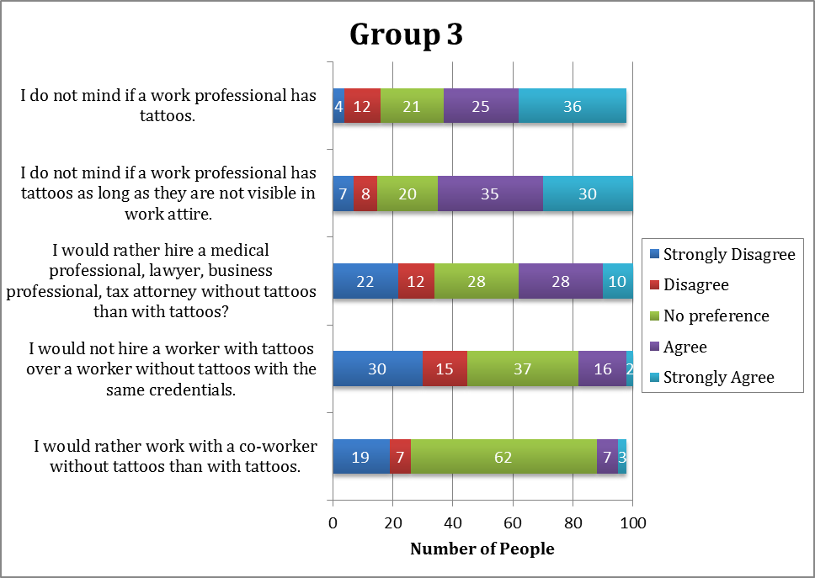strongly disagreed. This means that only 18% of the surveyors wouldn’t hire someone because of their tattoos. This is great information towards my final discussion on the research topic. Slightly contrasting this information is the results from the statement “I would rather hire a medical professional, lawyer, business professional, tax attorney without tattoos than with tattoos” there was a 211% rise (18 to 38 people) in the amount of surveyors who agreed or strongly agree with this statement than the previous statement. This directly means that more of the surveyors would rather hire a worker with tattoos for their company than they would hire an individual for their own services, such as a doctor or lawyer. A possible contribution to this change in data could be because the surveyors fear a discrimination lawsuit for their company if they did not chose to hire the individual, but would much rather have a professional without tattoos who they have the right to chose without possible lawsuits.If I had a chance to redo my data, I would add in a clause to not include the discrimination possibility when choosing their answer to the hiring workers with or without tattoos statement.

The final group of statements are based upon workers with tattoos. The first statement of interests is the first statement in Figure 8, not one surveyor chose “strongly agree” and only 3 people chose “agree” for this statement. This is great information for my final results, only 3% of the surveyors think that professionals without tattoos are more efficient, trustworthy, and proactive than professionals with tattoos. This adds to previous information found from the survey, because if they surveyors are feeling more accepting of tattoos in their lifetime, willing to work with someone with tattoos, do not mind if professionals have tattoos, but would rather hire a professional (personally, not for a company) without tattoos than with tattoos, and now 52% are claiming that professionals with tattoos are less trustworthy, efficient, and proactive, these are very contrasting ideals. It begins to show that when you start asking more in depth questions about tattoos, not only in day to day life, but in a professional setting, surveyors begin to start showing a negative opinion of tattooed individuals. Also, based on the next survey statement, 57% of surveyors believe that clients are intimidated by workers with tattoos. These are very drastic statements that both my stakeholders will find to be very valuable information. Although the group of surveyors, 57% said they believe clients are intimidated, 51% stated that they would not be against hiring a worker with these presumptions. But this brings us back to our previous information about the discrimination lawsuits against not hiring a worker based on physical attributes, so this could be a factor in the surveyors negative views on tattooed workers, but still showing an inclination to hire them. These survey results will be discussed in further detail in the final research paper.

**Works Cited**

Heywood, Wendy, et al. "Who Gets Tattoos? Demographic and Behavioral Correlates of Ever Being Tattooed in a Representative Sample of Men and Women." Annals of Epidemiology 22.1 (2012): 51-56. Print.